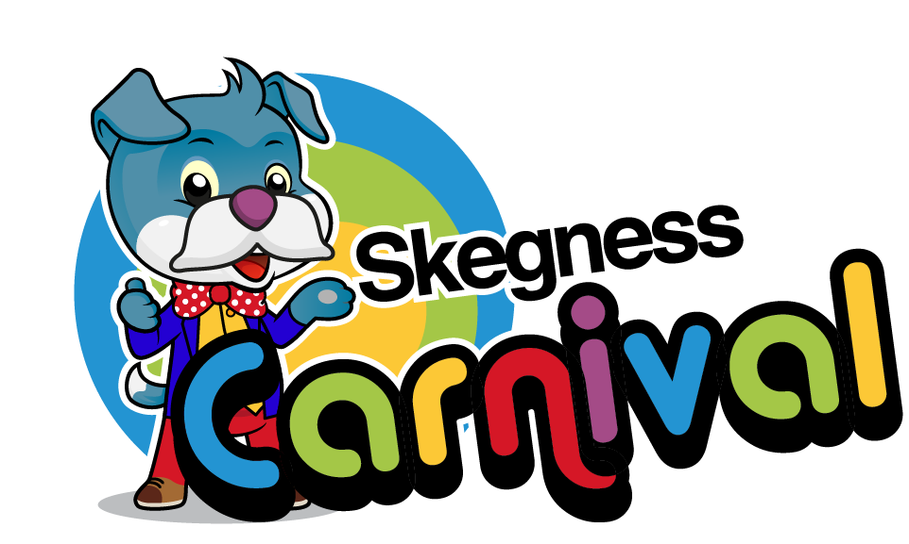

Attraction Application Form 2019
All attractions must submit an entry form and completed risk assessment form.

Name of Entry / Business

Contact Name

(Name of person responsible on the day)

Contact Address

Postcode

Email Address

Telephone Number

Mobile Number

(For person responsible on the day)

MAIN SPONSOR SECOND SPONSOR

PLEASE WRITE THE NUMBER OF ATTRACTIONS REQUIRED IN SPACE PROVIDED

Event | Location | Number of Attractions
Sunday 11th August  Parade Family Fun Day  Baby Show | Tower Gardens
Wednesday 14th August  999 Day  Pet & Dog Show | Tower Gardens

Description of Attraction(s)

Cost per attraction per day: £40*

PAYMENTS TO MADE IN FULL WITH APPLICATION
*Booking is not secured until full payment has been received

TRADING: 10.00am – 16.00pm (no earlier)
Early finish only if permission is granted in advance, otherwise you are requested not to pack away until the stated finish times.
We require a copy of your current Public Liability Insurance with the completed application. We also require a completed Risk Assessment form to be submitted at the time of application.

Due to space limitations, parking for one vehicle per stall will be granted. If generators are used then a current Electrical Safety Certificate, an appropriate fire extinguisher and risk assessment form including your fire precautions must be provided. Any fuel or flammable liquids must b bin approved containers.

It is mandatory that a safe area is maintained while stalls and equipment are being erected, therefore Stall Holder or Attraction will be allowed to set up until a member of the Carnival Committee and Safety Officer gives permission. If you have a valid reason to set up early then you must request this at the time of booking.

Please be aware that if you are selling homemade or home grown produce you require to be registered with ELDC Health Dept. Failure to do so may incur penalties ie. fines.

The Carnival Committee Members and Organisers accept no responsibility for loss, injury or accidental damage to persons or property, however caused. Skegness Carnival reserve the right to alter, amend or cancel any event.

All cheques made payable to ‘Skegness Carnival’ and sent to:

Skegness Carnival ℅ James Howsam
Click Ink Design & Print
Hardys Animal Farm
Anchor Lane
Ingoldmells
Lincs
PE25 1LZ

My signature, agrees that I have read and understand all the Carnival Rules. I am also submitting a completed risk assessment at the same time. Risk assessment forms are available to download from the Skegness Carnival website.
Signed _______________________________________________________
Print Name _______________________________________________________
Date _______________________________________________________

FOR OFFICE USE ONLY

INSURANCE | RISK ASSESSMENT | PAYMENT METHOD | INVOICE / RECEIPT NO.

